***PAAREES PERFUMES***

***VERSACE***

***FOR WOMEN***

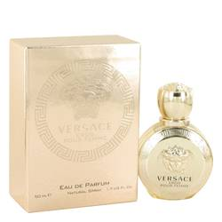

# 

# *Versace Eros*

# *Description:*

Versace Eros by Versace Perfume. The romantic spirit of the Roman god of love comes to life in Versace Eros. Released in 2014, this women’s perfume is a sensual blend of citrus and flowers. Sweet top notes of Sicilian lemon, Calabrian bergamot and pomegranate envelop the senses into a floral heart of jasmine, peony and lemon blossom. A woody base of sandalwood, ambrox and musk create a soothing balance to finish. Not overly feminine, this vibrant fragrance is for the passionate and sophisticated woman.  
  
Gianni Versace founded Versace in 1978 as an Italian fashion house. Still somewhat of a family business, the iconic brand is known for its clothing lines, accessories, jewelry and fragrances that are popular among celebrities. The Versace style is inspired by many forms of classic and contemporary art, and is influenced by Greek and Roman culture. Versace Eros is bottled in a gold flacon and packaged in a shiny gold box.